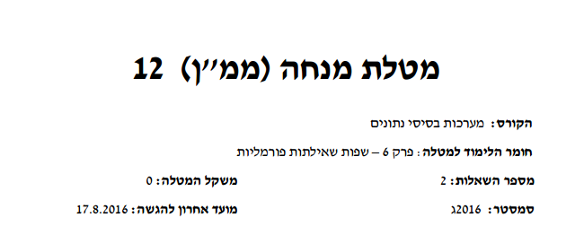

All RA signs:

|  |  |
| --- | --- |
| Projection | Π |
| Where clause | σ |
| rename relation \ rename column | ρ |
| rename column operator | ← |
| Order by | τ |
| group by | γ |
| AND | ∧ |
| OR | ∨ |
| Not | ∨ |
| OR | ¬ |
| equal | = |
| Not equal | ≠ |
| Bigger or equal | ≥ |
| less or equal | less or equal |
| Cross join | ⨯ |
| Natural join | ⨝ |
| left join | ⟕ |
| Right join | ⟖ |
| Full outer join | ⟗ |
| Left semi join | ⋉ |
| Right semi join | ⋊ |

Relation algebra:

We can use actual online database that have those tables

In this we site there is an online calculator that we can use exiting database of create our own.

The database is called group.

<http://dbis-uibk.github.io/relax/calc.htm#>

This is the database and the data I used for question 1.

In question 1.A we are asked to use client and file relations.

-- this is the database from maman 12 ( 2016c)

group: bank example

description[[ the data for this dataset was generated using <http://www.generatedata.com/>

* the relation _Customers_ contains basic information about the customers of the bank.

* the relation _Accounts_ contains the basic information of a single account. Note that a customer can have any number of accounts.

* the relation _PremiumCustomers_ contains the customer-ids of all customers with a total balance over 1000

]]

lawyer = { lname:string sdate:date hbiling:number partnet:date

ahoron 2016-01-01 200 2015-01-01

moshes 2016-01-01 200 null

yontan 2016-01-01 200 null

amir 2016-02-01 200 2015-01-01

amit 2016-03-01 200 2015-01-01

}

client = { cname:string tel:string address:string

eli 0504831232 rehovot

lital 0504831231 rehovot

mor 0504831234 rehovot

danny 0504831235 rehovot

}

File = { fid:number cname:string description:string status:date lname:string

103212 eli stolen null amir

103211 lital barelegry null amir

103213 danny kidnap null amir

103214 mor stolen null amir

103215 danny stolen 2016-06-02 amir

}

* Make sure that the table column name are correct , like cname

Otherwise the natural join will not work

The way I solved the relational algebra is to first do a sql query and then converts it to RA.

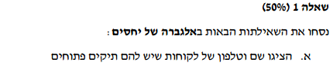

select client.cname, client.tel from file

natural join client

where file.status is null

Relational algebra does not have inner join, on ..

It does have natural join, which is inner join on common attribute names.

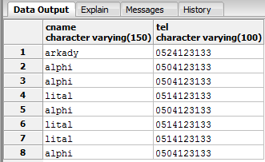

Now we can construct our RA:

π cname, tel (σ status = null (client ⨝ file))

This is how it looks in the calculator

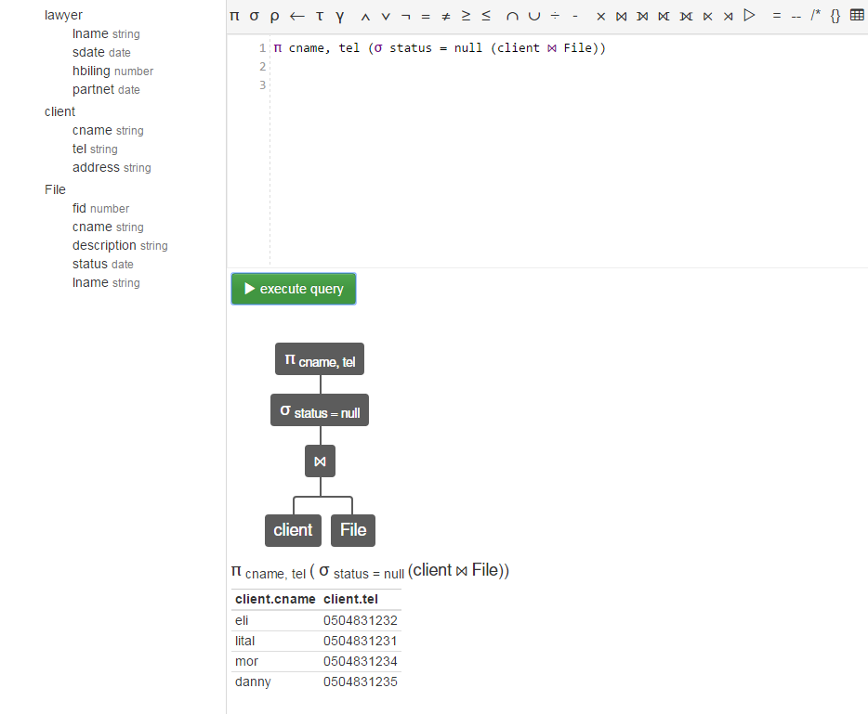

On the left we see our relations in the group.

And we can execute our RA query

Btw , to view the content of a relation just write the name of it and execute

For example:

